**Irish Kennedy Heritage Group**

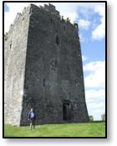**Mailing List No. 74 July. 2019**                       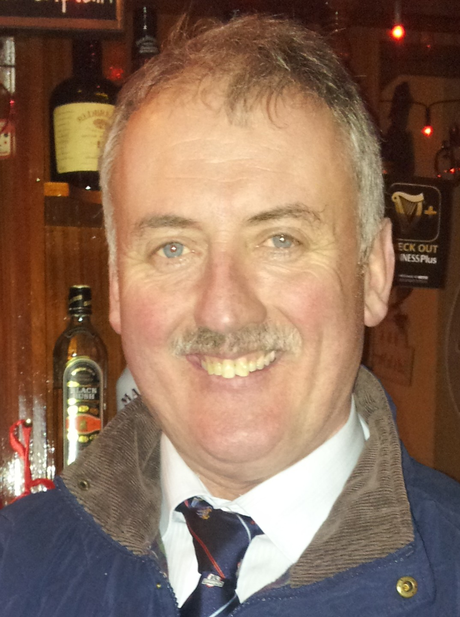

Lackeen Castle Chief Rody Kennedy

The mission of the Irish Kennedy Heritage Group is to research, preserve and disseminate

the history of the Irish Kennedys.

We

**Fáilte / Welcome.**

Welcome to our latest newsletter hoping that all our Kennedy members are well and happy wherever they live on our planet. Here in Tipperary all our focus is on our annual Clan Gathering happy in the knowledge that we will welcome visitors from Australia, U.S.A and many places in between. Summary of planned events underneath.

**Clan Gathering 2019.**.

***Sunday 14th July*** .

* Congregate in Chief Rody’s Angelsey lounge in Rearcross from 1.00pm
* Car trip to Brian Ború’s fort in Killaloe, original base of King Kennedy –brief history delivered by Brian Patrick Kennedy
* Return to Rearcross for launch of Brian Kennedy’s latest Kennedy book ‘The Irish Kennedys who moved eastwards – to baronies adjacent to Ormond’.
* Night of music, chat, refreshments and conviviality.

***Tuesday 16th July***

* 08.30. Coach trip to Dingle Peninsula, Co. Kerry***,*** home to 246 Kennedy families according to Griffith’s Valuation circa 1850. One small change to itinerary published in previous newsletter. Our first meeting with our Dingle Kennedys will still be in Annascaul, but in Joan’s cafe rather than South Pole Inn which has unfortunately been reserved by another coachload of tourists. A busy and hugely interesting and enjoyable rota of talks and events have been planned by our Kerry cousins. If you are interested in the trip to Dingle get in touch with any Committee member to help us with our coach hire arrangements. Return to Rearcross approx 9.00pm.

***Thursday 18th July.***

* 4.00pm. Visit by car to Rock of Cashel, ancestral seat of power of Kings of Munster
* Walking tour of Cashel facilitated by our Chairperson Donnchadh O Cinnéide
* Optional attendance at Brú Ború – a pageant of Irish music and dance.
* Optional car trip to Dunganstown, Co. Wexford, ancestral home of President John F Kennedy. The plan is that those who travel to Wexford will join up with the rest of the group in Cashel.

***Saturday 20th July.***

* Trip to Foilycleara of the many Kennedys who can trace their ancestry back to Foilycleara.
* For Kennedys who through the years have been connected to the Ryans you might wish to go to Pa’s Bar in Upperchurch on Saturday night around 8.00 pm where Brian will launch another book ‘The Ryans of Tipperary and Kilkenny.

For the rest of the week visitors will be able to seek out other places of Kennedy interest in North Tipperary whether they be homesteads, castles, churches, graveyards or Phyllis Kennedy’s lovely Irish Kennedy Display in the Heritage Centre in Nenagh. Your Tipperary cousins will be very happy to guide and help you.

Any queries or for further info contact me or any committee member at the contact points listed at bottom of this newsletter

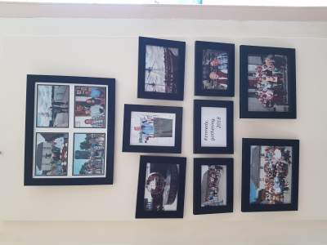

*Memories of Kennedy Clan 2018 Gathering on display in Heritage Centre*

Here is the slightly revised itinerary prepared by Micheál Ó Cinnéide for the trip to Dingle. As you will see it is a full but beautifully varied list of events which should prove to be educational, informative and highly entertaining, not to mention the magnificent scenery of the Dingle Peninsula. There will be a fee for the coach trip, €25 maximum, depending on numbers.

**Kennedy Heritage Trip to the Dingle Peninsula, 16thJuly, 2019**

**TurasnagCinnéideach go CorcaDhuibhne, DéMáirt, 16ú Iúil, 2019**

**08.30 Bus Departs**from**Kennedys of Rear Cross, Co. Tipperary**

(Drive via **M20**, **N21** Limerick-Adare- Castleisland and **N86** west of Tralee, **160** kms).

**11.00**amStop at **Joan’s Café Nua,**Main St, **Annascaul,**for coffee, scone&a briefing

(Meet Fr. Jerry Keane,PP and Tom Kennedy, farmer from Coole, Annascaul)

**11.30 Visit Ballinacourty**graveyard, near Annascaul(ref p. 284/5 of Brian Kennedy’s book)

(Many Kennedy tombs &the resting place of Tom Crean, explorer.)

**12.15**Visit **Garfinny graveyard**, near Lispole(Meet Tom Lynch.)

(Gravestone of Maurice Kennedy, 1816,as cited in “***The Dispersal Of Irish Kennedys***”, p.**291**)

**1.00pm**Drive west, via Dingle &around scenic Slea Head

Pause at **Dingle Workhouse** - C19 story of the Kennedys from CillMhica’Domhnaigh, Ventry.

**1.40**pm**Visit IonadAnBhlascaoid /Blasket Centre, DúnChaoin,** www. [blascaod@opw.ie](mailto:blascaod@opw.ie)

Light lunch &two short talks/discussion

* + **Dara Ó Cinneide**, Journalist/Footballer, on the story of the Kennedy brothers
  + **Lorcán Ó Cinnéide**, on the life of Fr. John Kennedy of West Kerry, Australia& USA.

**3.30**Drive to Dingle- **Clan Gathering** in **John Benny Moriartys**, [www.johnbennyspub.com](http://www.johnbennyspub.com)

* Fear & Bean a’Tí: **John Benny &Éilis Kennedy**
* Refreshments& music;Meet local historians &some of the West Kerry Kennedys.

**6.00**pmReturn bus trip from **Dingle - Rear Cross** (2 hours, 40 Mins, 180 kms)

**8.40/9**pmEstimated return to **Rear Cross, Co Tipperary**

***The rugged Dingle Peninsula area (from Annascaul west) has some of the highest densities of Kennedy descendants, outside of the North Tipperary “heartland”. The Griffith Valuation, c.1850 recorded 246 Kennedy occupier families on the Peninsula (“Dispersal Of Irish Kennedys”, p.292.) This trip will visit some of the places linked with “KerryKennedys”*.**

***Taylor Kennedy , Waterdown, Ontario, Canada.***

Taylor Kennedy lives in Canada and has amassed a huge amount of research and information on his Kennedy ancestry. His great grandfather Thomas Kennedy was born in Ontario, about 1849 and was son of William Kennedy, born 1806 of Knockadaleen, Terryglass, North Tipperary. Taylor is keen that the knowledge he has gained through his research be made available to the wider Kennedy clan and I am including some of the fruits of his labour in this edition. His work is centred mainly around the civil parishes of Terryglass and Finnoe and will be of particular interest to Kennedys whose ancestors hail from these areas. See below just two of the maps prepared by Taylor



Civil Parishes with townlands of Lower Ormond



**General Data Protection Regulations.**

You may have heard that the Data Protection laws are changing within the E.U. (possibly worldwide, not sure) from 25th May 2018 with the introduction of GDPR (General Data Protection Regulation). If at any stage, you no longer wish to receive newsletters or other communications from the Irish Kennedy Heritage Group please email me and I will delete your contact details from the database. We only hold your contact details so that you can receive information on I. K.H.G. news, meetings and events.

Your contact details will not be shared with any other party. You can unsubscribe at any time by emailing me.

**PREVIOUS NEWSLETTERS**

In order to make all earlier editions of the original mailing list generally available, Sean Kennedy has kindly volunteered to publish an **Internet Blog** that will provides appropriately edited posts in order from the first issue. You will find the Blog if you click on

<https://tikhg.blogspot.com>

**IRISH KENNEDYS BOOKS**

Internationally all books can be obtained via “The Irish Kennedys” web page at [https://theirishkennedys.weebly.com](https://theirishkennedys.weebly.com/" \t "_blank)

The Irish Kennedys books may be obtained in Ireland from:

**Chief Rody Kennedy’s Bar and Shop. Rearcross. Tipperary.  Ph. 062 79104**

**The Bookworm Bookshop. THURLES. Tipperary. Ph. 504 22257.**

**The Bookshop. Friar Street. NENAGH. Tipperary**

**The Kennedy Homestead, DUNGANSTOWN. Wexford. Ph. 051 388 264**

**Phyllis Kennedy, Garnafana, TOOMEVARA. Tipperary. Ph. 067 26069**

**Harvest Fresh, Main St. Borrisokane, Co. Tipperary. Ph. 3536727060.**

**Alan Hanna's Bookshop, 270 Rathmines Road Lower, DUBLIN 6**

**WARNING: Books are not available digitally on line. Do not provide credit card details to any site purporting to have digital copies available.**

|  |  |  |  |  |
| --- | --- | --- | --- | --- |
| [Picture](https://theirishkennedys.weebly.com/uploads/2/7/2/8/27289281/tiknew_1_orig.jpg) | [Picture](https://theirishkennedys.weebly.com/tmk1.html) | https://theirishkennedys.weebly.com/uploads/2/7/2/8/27289281/tmk-vol2-cover-1_1_orig.jpg | [Picture](https://theirishkennedys.weebly.com/uploads/2/7/2/8/27289281/tuokf_1_orig.jpg) | [Picture](https://theirishkennedys.weebly.com/tlok.html) |
| [Picture](https://theirishkennedys.weebly.com/jfk.html) | [Picture](https://theirishkennedys.weebly.com/bpkacl.html) | [Picture](https://theirishkennedys.weebly.com/ryans.html) | [Picture](https://theirishkennedys.weebly.com/dtik.html) | Next book:  The Irish Kennedys who moved eastward  To baronies adjacent to Ormond |

**Join the Irish Kennedys on Facebook**

**Click on the Kennedy chief inauguration with sub titles on You Tube**

<https://www.youtube.com/watch?v=KtsQKz-VAUw&feature=youtu.be>

Become a member of the Irish Kennedy Heritage Group and share your story.

Tom Kennedy

Email: tom.irishkennedyheritagegroup@gmail.com

Mob: 353876545646.